[](http://www.google.com/url?sa=i&source=images&cd=&cad=rja&uact=8&docid=ZeGHsYwDflARAM&tbnid=beqla2iR4E9BXM&ved=0CAgQjRw&url=http://www.picturesof.net/pages/101030-147567-281053.html&ei=qIgIVOivG43lsATU7YDgDA&psig=AFQjCNFBzbVUHLU-NHQRtbistjLziYrdhg&ust=1409931816539485)[](http://www.google.com/url?sa=i&rct=j&q=&esrc=s&source=images&cd=&cad=rja&uact=8&docid=VQErMRY4x_6u9M&tbnid=zctSa1ce5ZosJM:&ved=0CAUQjRw&url=http://www.clipartpanda.com/categories/football-clip-art-frames&ei=IYsIVO_OA4vGsQT28YKoBg&psig=AFQjCNF-di8AGS0UbDizwKS-0GsfTyBmkw&ust=1409932443428679)[](http://www.google.com/url?sa=i&rct=j&q=&esrc=s&source=images&cd=&cad=rja&uact=8&docid=t-I3HDA5nzgu_M&tbnid=G1-X67X-d6JP6M:&ved=0CAUQjRw&url=http://www.wps.k12.va.us/fdes2/parents/PTO.html&ei=eZ0IVKjqHM3lsASSioC4Cg&psig=AFQjCNHelGqmTyB3zCxGAC-N-Q4H1fvtmg&ust=1409937042900965)[](http://www.google.com/url?sa=i&rct=j&q=&esrc=s&source=images&cd=&cad=rja&uact=8&docid=VQErMRY4x_6u9M&tbnid=zctSa1ce5ZosJM:&ved=0CAUQjRw&url=http://www.clipartpanda.com/categories/football-clip-art-frames&ei=IYsIVO_OA4vGsQT28YKoBg&psig=AFQjCNF-di8AGS0UbDizwKS-0GsfTyBmkw&ust=1409932443428679)[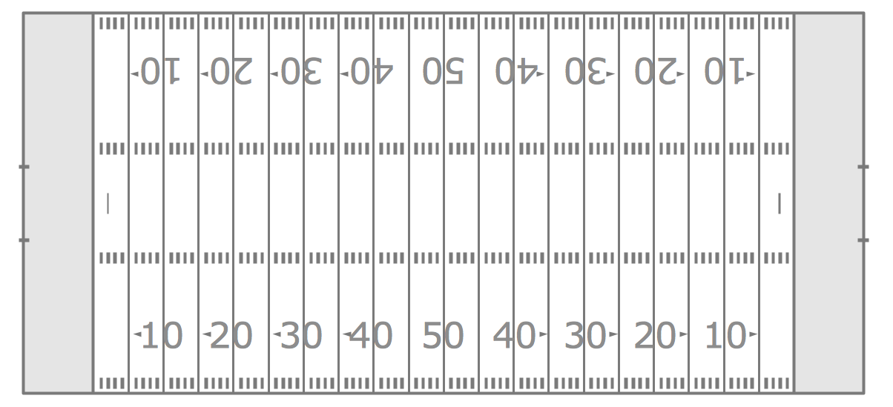](http://www.google.com/url?sa=i&source=images&cd=&cad=rja&uact=8&docid=m5TlYl602XH4MM&tbnid=hyc3VYp4Anw5dM&ved=0CAgQjRw&url=http://www.conceptdraw.com/solution-park/sport-football&ei=HogIVO6yNOu1sQSry4H4DQ&psig=AFQjCNH58k0JqybcppOcA0e8bnPoEsyLGA&ust=1409931678930065)

5

3

9

HOMER CENTER

HOMER CENTER

2

1

Attach one Box Top to each Football (using either glue or tape) Please DO NOT staple! Then bring it back to school to help your class win Box Top Wars. More collection sheets available at the office!

20

19

18

17

15

14

13

12

16

11

10

8

7

6

4

Name___________________________________

Teacher_________________________________

**Friday Night Football **